FLOCKv1



**Instruction Manual**

**by Austin Pittman Ladshaw**



Artwork by Iris Tsouris

Table of Contents

Getting Started 3

Mac OSX 3

Xcode 3

User’s Guide 7

GSTA_OPT 7

Input Files 7

Executing the Kernel 8

Kernel Output 8

MAGPIE 10

Input Files 11

Executing the Kernel 12

Kernel Output 13

SKIMMER 13

# Getting Started

The FundamentaL Off-gas Collection of Kernels (FLOCK) is distributed as raw source code. As such, in order to utilize this software you must build your own binary, or executable file, by compiling the source code on your particular machine. Additionally, the FLOCK is not distributed with a make file, so you will need to use an integrated development environment (IDE) software, such as Visual Studio, eclipse, or Xcode, in order to compile and build the binary.

## Mac OSX

The following instructions have been tested and work for Mac OSX 10.8 and higher.

### Xcode

Xcode is free to download from the Apple App Store and already comes equipped with all the tools and compliers necessary to build and run the FLOCK. Below are step-by-step instructions to building and compiling the FLOCK in Xcode 4.6 and higher.

**Step 1:** Download and install Xcode from the App Store. You may need administrative privileges for your computer and a valid Apple ID.

**Step 2:** Next you must download and install the command line tools. Go to Xcode preferences under the Downloads tab and click install for the Command Line Tools.

**Step 3:** Create a new Xcode project by clicking on File -> New -> Project. You will then be prompted to choose a template for your project. Under OS X, choose Application, then Command Line Tool, and click Next (Figure 1). Provide the name of the product (i.e. FLOCKv1 or what ever you want to call it), then for the type choose C++ and click Next. Now you can choose the working directory of your project. Location does not matter, just put it anywhere that is convenient. All source code and related project files will be placed in this directory. Once you have chosen a location, click Create.

After your project has been created, Xcode will open up the code editor for your new project (Figure 2). On the left hand side of the editor is the navigation area (outline in red on Figure 2), which will show all of your source code files and binaries. The center of the screen contains your standard code editor window (outlined in green) and the right side shows your utilities menu (outlined in blue). The bottom portion of the window shows the debug area (outline in purple) and the console output window (outlined in orange). Each of these windows can be toggled off and on under view options.

If you click on any source code file in the navigation area of the editor, Xcode will open that file in the editor window and show you all of the raw code (color coded).

Hint: You can view the line numbers of the code by going under Xcode Preferences under the Text Editing -> Editing tab.

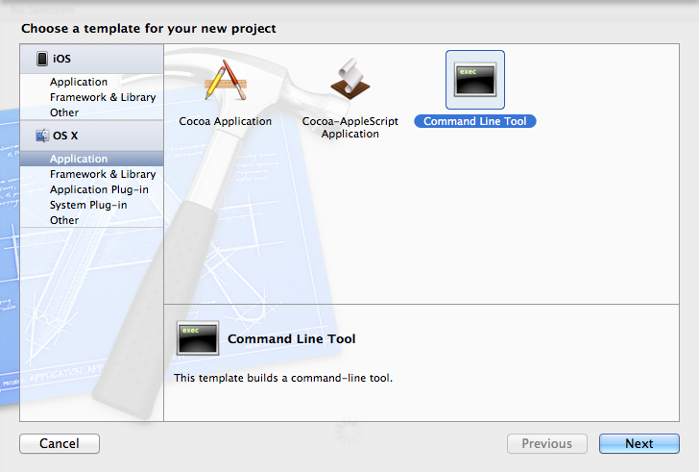

Figure 1: Creating a new project to run the FLOCK from.

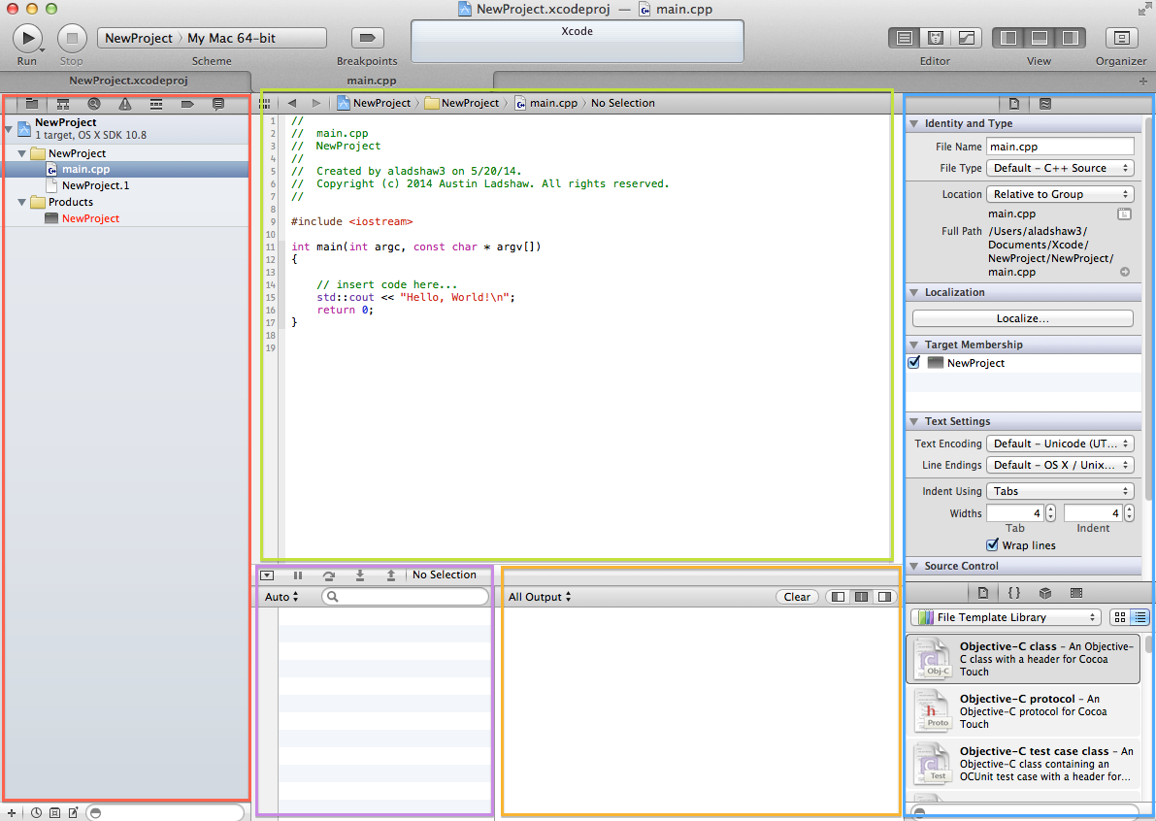

Figure 2: View of the Xcode editor. You can navigate through source code files from the left and edit the contents of those files in the central editing window. Console output and debug information is shown below and your utilities and options are on the right.

**Step 4:** Xcode, by default, supplies your project with a main.cpp file, which you must replace with the one provided in the FLOCK. Start by right clicking on this file in the navigator and delete the file. Be sure to use option “Move to Trash” and NOT “Remove the Reference”.

Now, right click on the folder holding the source code files in the navigation area. This is the folder called “NewProject” in Figure 2 above. Select “Add Files to…” and you will be prompted to locate source code files that you would like to add to your project. Locate and select all of the FLOCKv1 source code files from your computer. NOTE: Be sure to check the box labeled “Copy items into destination group’s folder”, otherwise the source code files will only be linked to the project and not copied to it. Click “Add” to add the source files to the project.

**Step 5:** You are now ready to build your binary. Start by selecting File -> Save (press command+S), then go to Product -> Build (press command+B). Xcode will compile the source code and create a binary/executable. If the build did not succeed, Xcode will display any warnings or errors in the navigation area under the Issue Navigator (seen as a triangle with an exclamation mark).

**Step 6:** You can run the binary from within Xcode by going to Product -> Run (press command+R) or by pressing the Run button at the top left of the editor. However, the code will immediately spit an error. This is because the binary you just created cannot find the input file necessary to execute the program as directed (Figure 3).

To fix this, you must put the all input files related to the FLOCK into the directory of the binary file. Your binary file will be located under /Users/youruserid/Library/ Developer/Xcode/DerivedData/projectname/Build/Products/Debug (or Release, which ever one was built for).

Note: By default, Mac OSX hides the Library folder from the user. However, you can make this folder visible again by doing one of the following:

*OSX 10.8:* Open up the Terminal application (/Applications/Utilities/Terminal.app) and type the following: “chflags nohidden ~/Library/” without the quotation marks. Then, close and reopen the Finder and the Library folder should now be visible.

*OSX 10.9:* Open Finder and go to View -> Show View Options and check the box that says “Show Library Folder”.

Note: This is only necessary if you are using the default text input for running the FLOCK by itself and does not apply if you are integrating these codes into your own model/source code framework. For this, you will use your own type of input and will not use the standalone executions of each kernel.

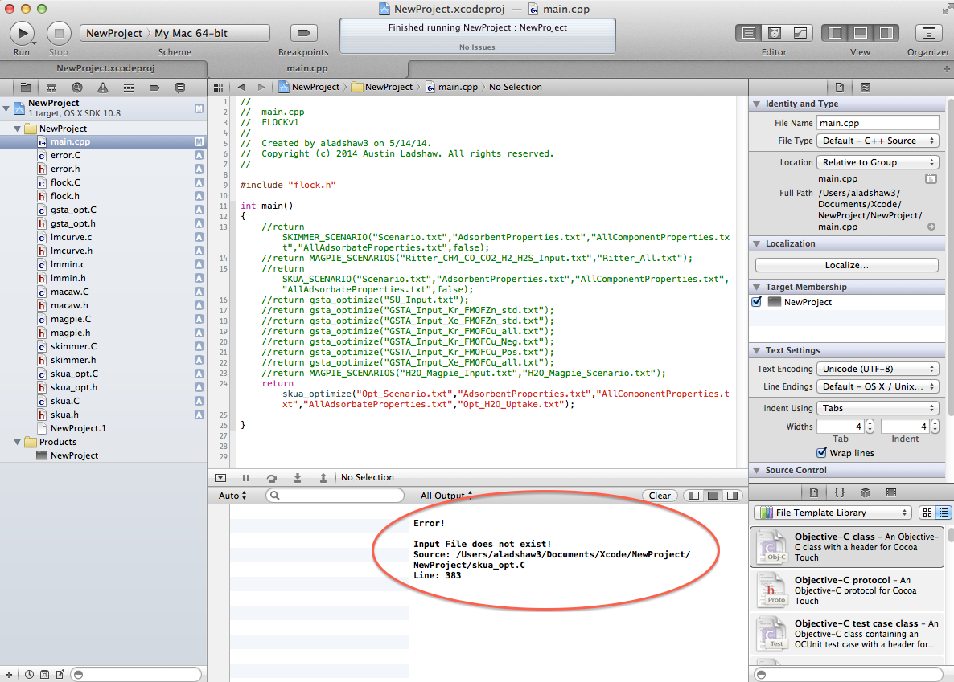

Figure 3: Circled in red is the error you would receive if trying to run the source code immediately without putting the input files into the binary directory. Note that these errors, and many others like them, are predefined errors from the source code itself and do not reflect any kind of build error.

**Step 7:** Once you have copied all the input and output files provided with the FLOCK into the binary directory, you will be able to successfully run the code. You can also add links to the input files from the editor so that these files can be viewed and edited in Xcode. To do this, you will right click on the Products folder in the navigation area and select “Add Files to…”. Locate the input files that you just copied into the binary directory earlier, then deselect the “Copy items into destination group’s folder” before clicking Add. Remember, we only want to create links between the editor and input files, copying the files into the project directory will do nothing for us.

Now the input and output files from the FLOCK should appear below the Products folder in the navigation area, which can be opened and edited inside Xcode.

Hint: Press command+T to open a new editor tab in Xcode. This will allow you to have open multiple input, output, or source files for quick viewing and editing.

**Step 8:** Rebuild (press command+B) and rerun (press command+R) the source code and the application should now run to completion. You are now ready to start using or developing in the FLOCK!

# User’s Guide

The following gives an overview of all the current kernels and codes available to the typical user of the FLOCK. This guide is not intended to aid persons wanting to develop within the FLOCK framework. See Developer’s Guide for greater detail.

## GSTA_OPT

This kernel is designed for equilibrium data analysis for single species, gas-solid adsorption isotherms. The intent and design of this code is to take in a series of adsorption isotherms, via text file, and attempt to correlate that data with the Generalized Statistical Thermodynamic Adsorption (GSTA) isotherm model (shown below in equations 1 and 2.

 (1)  (2)

The parameters that the kernel solves for are *q*max (theoretical maximum adsorption capacity), *m* (number of energetically distinct adsorption sites), Δ*Hon* (enthalpy of the *n*th site), and Δ*Son* (entropy of the *n*th site). Input data for this kernel are the equilibrium amounts adsorbed (*q*) versus the pressures (*p*) in the gas phase at which that equilibrium is obtained. Variable *Po* is the standard state pressure, taken to be 100 kPa.

### Input Files

To run the GSTA_OPT kernel requires an input file of data formatted as follows:

M – Number of isotherms (integer)

*q*max – Theoretical Maximum Adsorption Capacity (double) – {mol/kg}

*T*1 – Temperature of isotherm 1 (double) – {K}

N1 – Number of data points of isotherm 1 (integer)

*p*1,1 – Pressure 1 – {kPa} [\tab] *q*1,1 – Adsorbed Amount 1 – {mol/kg}

…

*p*N,1 – Pressure N1 – {kPa} [\tab] *q*N,1 – Adsorbed Amount N1 – {mol/kg}

*T*2 – Temperature of isotherm 2 (double) – {K}

N2 – Number of data points of isotherm 2 (integer)

*p*1,2 – Pressure 1 – {kPa} [\tab] *q*1,2 – Adsorbed Amount 1 – {mol/kg}

…

*p*N,2 – Pressure N2 – {kPa} [\tab] *q*N,2 – Adsorbed Amount N2 – {mol/kg}

… …

*T*M – Temperature of isotherm M (double) – {K}

NM – Number of data points of isotherm M (integer)

*p*1,M – Pressure 1 – {kPa} [\tab] *q*1,M – Adsorbed Amount 1 – {mol/kg}

…

*p*N,M – Pressure NM – {kPa} [\tab] *q*N,M – Adsorbed Amount NM – {mol/kg}

Note: If the *q*max parameter is unknown, you can put a zero (0) in it’s place and the routine will try to estimate this parameter as well.

### Executing the Kernel

In the main.cpp file of the FLOCKv1 project, we can call the GSTA_OPT kernel or any other FLOCK kernel with a few simple lines of code. This will be the only user interface required to run these programs.

**Step 1:** First set up the input file you want to use for the kernel. Format it correctly and give it the extension “.txt”.

**Step 2:** Place that text file into the directory of the binary created by FLOCKv1 (for detailed instructions, see Step 6 through 7 from Xcode section pages 5 and 6).

**Step 3:** Set up the main.cpp file as shown below:

#include “flock.h”

int main()

{

return gsta_optimize(“Input_File_Name.txt”);

}

**Step 4:** Rebuild the source code and run the new binary.

Note: DO NOT put any white space in the file name!

Hint: When you want to run a different kernel, the only thing you must change is the return line.

### Kernel Output

Upon completion of the kernel’s execution, the analyzed data and results will be printed out to a series of output text files. Some data and information will be printed out to the console window, but the most bulk of the formatted data will always be printed out in text files. Those text files are tab separated to allow for easy transfer into excel, or another spreadsheet program, for analysis.

#### All_Results.txt

The optimization routine will go through all possible forms of the GSTA model to try and find the optimal value of *m*, the number of adsorption sites. In the “All_Results.txt” file, all the best-fit results will be displayed for each value of *m* that was tested, for all isotherms from the input data. However, the values of *q*max and *m* must be a constant for the entire system, so these results do not represent the final results. If the user decides that the final results are not satisfactory, then they can use these results to choose the value of *m* that they deem most suitable for the system.

The data in this output file is as follows:

Isotherm number and temperature

Optimized parameters: *q*max and *Kn*’s

Euclidean norm of the fit and the objective function value

Pressure input, adsorbed observation, adsorbed estimation, and residual

Note: The *Kn*’s are related to the *Kon*’s from equation 1 through the standard state pressure: *Kon* = *Kn*(*Po*)*n*. The objective function is a penalized version of the Euclidean norm and is designed to root out which value of *m* is most suitable across all isotherms.

#### Best_Results.txt

The “Best_Results.txt” output file displays the same information and same formatting as the “All_Results.txt” file, but only gives results for the optimal value of *m* for all isotherms. You can take this data and copy into an excel file for plotting the optimized results against the actual data. The *Kn* parameters in this file should theoretically have a dependence on temperature as equation 2 indicates. This analysis is performed by the code and is output in the next file.

#### Energy_Results.txt

For general modeling purposes, these results are the most important ones. This file contains the optimized enthalpies and entropies of each different adsorption site of the adsorbent. These parameters are unique to each adsorbate-adsorbent pair and can be used to predict how the system will behave at different temperatures.

Along with these results is a value labeled “R_Squared” for each enthalpy and entropy pair. This is the corresponding *R*2 value that is taken from an orthogonal linear regression of the *Kon* parameters obtained from “Best_Results.txt”. If the linear regression was successful, then this value should be close to 1. If *R*2 is not close to 1 (i.e. less than 0.9), then this indicates that the *Kon* parameters did not have the expected linear relationship with temperature. You can use the next output file to examine the temperature relationship more closely.

#### Parameter_Results.txt

The last output file summarizes the optimum parameters found for each isotherm. It also gives the estimated Gibb’s free energy of adsorption (Δ*Gon*) for each adsorption site and Henry’s law coefficient (*He*) at each temperature. If the enthalpies and entropies estimated from the “Energy_Results.txt” file did not have a good R2 value, then the *Kon*’s from this file can be plotted against temperature to view what type of temperature relationship is occurring in the adsorption system.

Note: All other simulations count on this linear temperature relationship, so if the observed relationship here is non-linear, then you must look at doing a piece-wise linear regression on the *Kon*’s. This way the linear temperature relationship will be at least valid within specific temperature ranges. Temperature ranges for each subsequent simulation must then be limited and differentiated by which parameters (enthalpies and entropies) apply within that range.

## MAGPIE

Multicomponent Adsorption: Generalized Procedure for Isothermal Equilibria (MAGPIE) is designed to perform a single- or multi-component equilibrium prediction based on the single-component adsorption behavior of each adsorbing species in a gas mixture, as well as the system pressure and temperature. It uses the GSTA model, as the isotherm equation, combined with the Generalized Predictive Adsorbed Solution Theory (GPAST) system of equations and the Modified Spreading Pressure Dependency (MSPD) activity model to describe the non-idealities of the adsorbed phase. Equations 3 through 20 outline the system of equations, which MAGPIE solves for each scenario given on input.

 (3)  (4)

 (5)

 (6)  (7)  (8)

 (9)

 (10)  (11)

 (12)  (13)

 (14)  (15)

 (16)  (17)

 (18)

 (19)  (20)

Obviously, the above system of equations is far too complex to be solved analytically. Therefore, the workings of MAGPIE goes through the entire system incrementally and simplifies the calculations down to a set of smaller subsystems, which are each solved iteratively. However, for using MAGPIE, it is not necessary to be familiar with the all of the intricacies of the mathematical procedure, so we will skip a detailed explanation of the system and move on how you, the user, will interface with it.

### Input Files

Unlike the GSTA_OPT kernel, the MAGPIE kernel requires two different, formatted text files on input: (i) a Parameters File and (ii) a Scenario File. For the Scenario File, there are two different types of sub-files, which determine whether you are running a forwards scenario (i.e. giving the gas phase composition to solve for the adsorbed phase) or backwards scenario (i.e. giving the adsorbed phase composition to solve for the gas phase). Each type of file and format is given below.

#### Parameters File

The Parameters File contains the GSTA isotherm parameters for each adsorbing species present in the gas mixture. Note that an underlying assumption in MAGPIE is that all species are adsorbing onto the same adsorbent, therefore these parameters must reflect the behavior of each pure species on that particular adsorbent. The format of the input file is as follows:

*N* – number of adsorbing species (integer) – [\newline]

*v*1 – van der Waals volume of species 1 (double) – {cm3/mol} – [\newline]

*q*max1 –adsorption capacity of species 1 (double) – {mol/kg} – [\newline]

*m*1 – number of adsorption sites for species 1 (double) – [\newline]

Δ*H*1,1 – enthalpy of site 1 for species 1 (double) – {J/mol} – [\tab]

Δ*S*1,1 – entropy of site 1 for species 1 (double) – {J/K/mol} – [\newline]

…

Δ*Hm*,1 – enthalpy of site *m* for species 1 (double) – {J/mol} – [\tab]

Δ*Sm*,1 – entropy of site *m* for species 1 (double) – {J/K/mol} – [\newline]

… …

*vN* – van der Waals volume of species *N* (double) – {cm3/mol} – [\newline]

*q*max*N* –adsorption capacity of species *N* (double) – {mol/kg} – [\newline]

*mN* – number of adsorption sites for species *N* (double) – [\newline]

Δ*H*1,*N* – enthalpy of site 1 for species *N* (double) – {J/mol} – [\tab]

Δ*S*1,*N* – entropy of site 1 for species *N* (double) – {J/K/mol} – [\newline]

…

Δ*Hm*,*N* – enthalpy of site *m* for species *N* (double) – {J/mol} – [\tab]

Δ*Sm*,*N* – entropy of site *m* for species *N* (double) – {J/K/mol} – [\newline]

Note: If your gas mixture contains non-adsorbing species, they will all be lumped together as a “carrier gas” and do not need to be placed in this input file.

#### Forwards Scenario File

For the Forwards Scenario File, you must give the gas phase composition of the mixture for a series of temperatures and pressures. The output from MAGPIE will be the theoretical adsorbed amounts and composition based off of that input information. Formatting for this input file is as follows:

Flag (integer) – either 0 (forwards) or 1 (backwards) – [\newline]

M – Number of Scenarios (integer) – [\newline]

*PT*,1 – Total pressure of scenario 1 (double) – {kPa} – [\tab]

*T*1 – Temperature of scenario 1 (double) – {K} – [\newline]

*y*1,1 – Gas mole fraction of species 1 for scenario 1 – [\tab]

…

*yN*,1 – Gas mole fraction of species *N* for scenario 1 – [\newline]

… …

*PT*,M – Total pressure of scenario M (double) – {kPa} – [\tab]

*T*M – Temperature of scenario M (double) – {K} – [\newline]

*y*1,M – Gas mole fraction of species 1 for scenario M – [\tab]

…

*yN*,M – Gas mole fraction of species *N* for scenario M – [\newline]

#### Backwards Scenario File

The Backwards Scenario File has a very similar format, but contains a little more information. Here, you must specify what the total amount adsorbed is along with whether or not there is a carrier gas (i.e. inert or non-adsorbing gas) present in the system. The format for this file is as follows:

Flag (integer) – either 0 (forwards) or 1 (backwards) – [\newline]

M – Number of Scenarios (integer) – [\newline]

*PT*,1 – Total pressure of scenario 1 (double) – {kPa} – [\tab]

*T*1 – Temperature of scenario 1 (double) – {K} – [\newline]

*qT*,1 – Total adsorbed amount of scenario 1 (double) – {mol/kg} – [\tab]

Carrier Flag (integer) – either 0 (no carrier) or 1 (carrier) – [\newline]

*x*1,1 – Adsorbed mole fraction of species 1 for scenario 1 – [\tab]

…

*xN*,1 – Adsorbed mole fraction of species *N* for scenario 1 – [\newline]

… …

*PT*,M – Total pressure of scenario M (double) – {kPa} – [\tab]

*T*M – Temperature of scenario M (double) – {K} – [\newline]

*qT*,M – Total adsorbed amount of scenario M (double) – {mol/kg} – [\tab]

Carrier Flag (integer) – either 0 (no carrier) or 1 (carrier) – [\newline]

*x*1,M – Adsorbed mole fraction of species 1 for scenario M – [\tab]

…

*xN*,M – Adsorbed mole fraction of species *N* for scenario M – [\newline]

Note: Both the forwards and backwards solutions are fully reversible to within 10-6 accuracy. Meaning, if given gas phase composition A results in adsorbed phase B, then given adsorbed phase composition B will result in gas phase composition A up to that accuracy.

### Executing the Kernel

Running the MAGPIE kernel is carried out in the same way as running the GSTA_OPT kernel. It only requires that you replace the return statement and rebuild the source code to form a new binary. You will be required to rebuild the source code every time a change is made in code. The new return statement in the main.cpp file would be as follows:

return MAGPIE_SCENARIOS(“Parameter_File_Name.txt”, “Scenario_File_Name.txt”);

### Kernel Output

During runtime, the kernel will output various stages of the solution to the console and periodically state whether or not a simulation/scenario was successful. At the end of execution, the program displays the total runtime of the code along with the average and maximum norms, or errors, associated with solving all parts of the MAGPIE system of equations (equations 3 through 20).

The results of the simulations are all output to a single text file called “Scenario_Results.txt”. This file tabulates the temperatures, pressures, gas phase mole fractions, total amounts adsorbed, adsorbed mole fractions, and overall spreading pressure (Π) for each scenario. These results can be copied into excel, or other spreadsheet program, for further data analysis and graphing.

## SKIMMER

Sorption KInetic Models for Mass transfER (SKIMMER) is designed to numerically solve a coupled system of partial differential equations (PDEs) (equations 21 through 27), and several linear and non-linear equations (equations 28 through 48), associated with the diffusion of gas molecules into spherical, biporous, commercial adsorbent pellets. The code is inherently multicomponent and requires input information for each gas species *i* in the mixed system.

 (21)  (22)

 (23)

 (24)  (26)

 (27)  (28)  (29)

 (30)  (31)

 (32)  (33)

 (34)  (35)

 (36)

 (37)  (38)

 (39)  (40)  (41)

 (42)  (43)  (44)

 (45)  (46)  (47)

 (48)

Note: In equation 24, we DO NOT apply the isotherm. Instead, we take the concentration at the edge of the adsorbent crystal (*cc,i*) to be the concentration in the pore space (*ci*) at a particular location in the pellet. SKUA replaces this boundary condition by applying the isotherm, or MAGPIE simulation, and solves for the actual adsorbed amount over time.

Hint: